**Function Increase and Decrease**

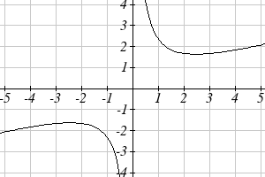

1. Use the graph to estimate the intervals on which the function is increasing, .

For each function graphed, estimate the intervals on which the function is increasing and decreasing.

2. 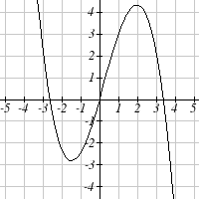 3. 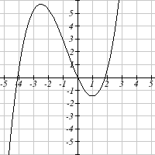

4. 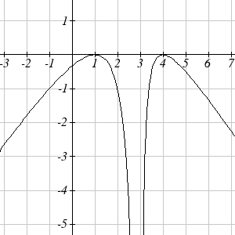 5. 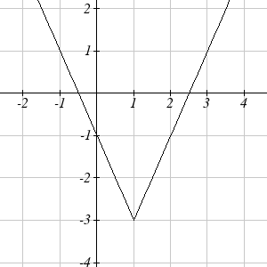

Determine the interval(s) on which the function is increasing and decreasing use desmos.

6.  7. 

8.  9. 